Pedibus Development

Final Design Report

Sponsor:

Ron Goldstein Capital City Pedicabs

Facultiy Advisor:

Dr. Patrick Hollis

Team:

Andrew Galan Team Leader amg10x@my.fsu.edu

John Hassler Web Design Officer jdh03c@my.fsu.edu

James McCord Financial Officer jtm09f@my.fsu.edu

Onyewuchi Ebere Lead M.E. ebere.onyewuchi@yahoo.com

**Executive Summary**

Capital City Pedicab Company and its owner Ron Goldstein have entrusted the Florida State University mechanical engineering department to aid and assist in their overall goal of setting up a manufacturing station of fully operating Pedibus system in the southeast region of the United States. The development of a Pedibus transportation vehicle involves various amounts of mechanical components and evaluations. As the first semester is coming to an end, the development of this project is appropriately on schedule. The final design of the Pedibus has been developed and analyzed. The production of the road-ready prototype is ready to begin. Selected material and manufacturing options have been budgeted to make the safest and most cost effective vehicle. Being in immediate contact with the sponsor and positive communication has allowed for the construction of the vehicle prototype to begin in the upcoming semester and hopefully meet the personal goal date of completion.

**Table of Contents**

I. Acknowledgment pg. 1

II. Project Overview pg. 1

A .Project Goal pg. 1

B. project Objective pg. 2

C. Constraints pg. 2

III. Design and Analysis pg. 2

A. Function Analysis pg. 4

B. Design Analysis pg. 3

C. Dynamic Analysis pg. 10

IV. Risk and Reliability Assessment pg. 17

V. Detailed Design and Design for Manufacturing pg. 17

VI. Procurement pg. 18

VII. Communications pg. 19

VIII. Conclusion pg. 19

IX. Environment and Safety Issues pg. 20

X. Future Plans pg. 20

XI. Budget and Resources pg. 20

XII. References pg. 21

**I. Acknowledgement**

We wish to acknowledge the following for the respected support and guidance thus far into the senior design project development:

The Florida State University – Florida Agricultural & Mechanical University School of Engineering for allowing us the opportunity to work with external companies to gain project development experiences.

Instructor Dr. Kamal Amin for evaluation and positive feedback. Faculty Advisors Dr. Chiang Shih and Dr. Patrick Hollis for helping with problem solutions referring to the development of this project.

Special acknowledgement is given to Capital City Pedicabs, and in particular CEO, Mr. Ron Goldstein, for providing us with the sponsorship and ability to provoke on such a rewarding development project.

**II. Project Overview**

The overall purpose through this development project is to aid in the assistance for Capital City Pedicabs is to start the production and manufacturing of Pedibuses in the southeast region of the United States. To do this the purpose of this semester has been to develop concept ideas and analysis to review with the sponsor and lead to the construction of a fully operating road-ready Pedibus. The beginning process of this project dealt with structural and aesthetic concept designs. Kinematics and ergonomics were taken into account, as well as the budgeting and selection of necessary materials and items to construct the prototype.

**A. Project Goal**

Developing and manufacturing a fully functional prototype pedibus by the end of April 2014, is the priority goal for the project. The development of the prototype will provide information about dynamic and structural design, along with cost and maintenance recommendations. The Pedibus is to be eco-friendly and safe to the public. It is expected to be efficient enough that it can be powered by only two people.

**B. Project Objective**

The objectiv of this project is to design and build a multi-passenger prototype vehicle that is powered by pedal inertia. The prototype will be used as a guide for the set up of a Pedibus manufacturing station. The design is to take safety and maintenance considerations into account when considering every component. There are several parameters that had to be met to reach the final goal. These included:

* Developing the size of the vehicle based on the number of desired passengers and relative price points of the material and construction costs.
* Designing an appropriate frame structure that is lightweight and has optimal strength.
* Design the linkage system that will be connected to the drive shaft, to integrate a power drive system.
* Decide on the type of steering and braking to use on the vehicle that will provide a safe, comfortable ride.
* Decide on tires and wheel to reduce unwanted frictional forces
* Integration of a power assistance motor and battery to power vehicle and safety lights.

**C. Constraints**

Several constraints have been altered from the initial design of this project with the approval of the sponsor. Constraints experienced this semester have been overcome, but are still necessary to list for means of discussion. They are:

* Starting budget of $2,000 – Current budget set at $5,000
* Low manufacturing cost to validate for cost effective reproduction
* The weight of the vehicle traveling up an inclination or without passengers will require motor power assistance.
* Maintenance has to be minimal, simple, and inexpensive.
* State automotive street laws have to be considered and applied to secure the safety of the public.

**III. Design and Analysis**

The development can be broken down into three main subcategories; structural, steering and braking, and power linkage. These are the main components that required numerous conceptual designs and analysis to ensure to cheapest, lightest, and safest Pedibus.

**A. Function Analysis**

The Pedibus is developed around the idea that it is an eco-friendly, pedal inertia powered entertainment vehicle. The passengers are assigned to individual peddling stations and as the peddles move and rotate the operating components the vehicle will begin to move; much like a common bicycle. The proceeding section will discuss the functionality of each major subcategory.

**i. Structural Frame**

The primary task of the frame is to tie together all of the separate components of the vehicle in a safe and secure fashion. Considerations taken into account in design of the frame are strength, safety, weight, and maintenance. Strength is the most pivotal aspect. The frame needs to be strong enough to withstand forces larger in magnitude than what is to be expected in normal operation. Primarily, the loads will be downward forces, but lateral forces as well as acceleration and deceleration forces are taken into account and planned for.

**ii. Steering and Braking**

The control operation of the Pedibus has to be safe and simple to provide ease of maintenance and control. The steering system is responsible for turning the wheels either left or right depending on the orientation of the wheel determined by the central driver. As the driver rotates the steering which through a gear set will translate the rotational motion into a linear transitional motion. Once the Pedibus is in motion, determining the best stopping method has to be taken into great consideration to apply the best possible public safety. Normal automobiles have brakes that are used to reduce the speed of a vehicle to come to a complete stop. The same idea goes into the stopping of the Pedibus. As force is applied to the brake pedal by the driver the rotor will begin to slow down until all kinetic energy is lost and come to a complete stop. Both braking and steering are going to be located at the front central driving station, and not at the pedaling stations, to ensure that the proper steering and braking applications are made.

**iii. Power Linkage**

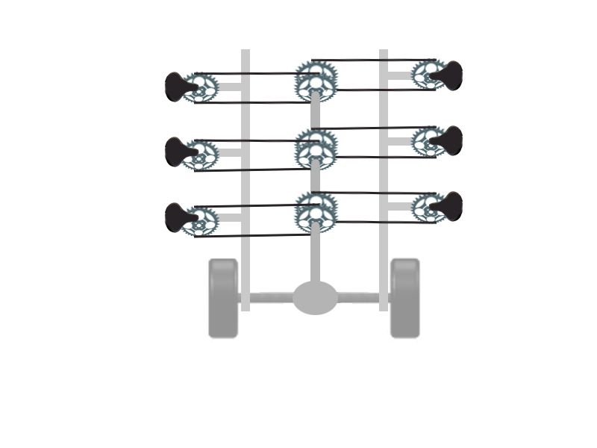The power linkage of the Pedibus system works under the principle that the passengers input the power required to move the vehicle. This power input is accomplished by the passengers pedaling at the pedaling station. The pedaling power input by all passengers is then converted into the motion of the Pedibus. Early in the semester the Pedibus team researched how other Pedibus manufacturers had accomplished this transmission of power from the pedals to the wheels of the vehicle. Viewing the information posted on several different Pedibus manufacturers’ websites it was observed that all existing Pedibuses have the pedaling power input to a central drive shaft. This drive shaft is connected to a rear differential from an automobile. After exploring other options through the course of the semester the Pedibus team has decided to implement this functional design in the vehicle we are developing. Figure 1 is a simple diagram of how our team initially visualized the linkage between the pedaling stations, drive shaft, and rear axle of the vehicle.

Figure 1. Initial Power Linkage Design

**B. Design Analysis**

The design of the prototype is the back-bone to the Pedibus development. Multiple concept design and errors had to be overcame to provide the most simple and safest design. The design of a prototype is the stepping stone for possible production, since it is typically the first thing a company brings a consumer to review. The designs that will be discussed have been analyzed and chosen for the ease of maintenance and reliability.

**i. Structural Frame**

The weight of the frame is a large factor in how much power input each of the passengers of the Pedibus will need to input to accelerate and maintain its velocity at the desired cruising speed of 5 mph. Due to the tourist friendly nature of the vehicle, an enjoyable experience for the passenger is necessary. The lighter the frame the more enjoyable the experience for the passenger. In an effort to minimize the weight of the frame as much as possible, while still retaining strength, different materials were explored. The primary materials taken into consideration were steel and aluminum. Steel is a very strong material and monetarily fits within the budget. It is roughly 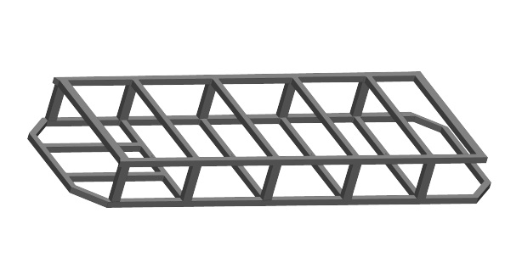twice as strong and three times as heavy as aluminum. The initial lower frame design composed of only steel and is shown in figure 2. This frame was made of 2x2 rectangular tubing with wall thickness on 0.125 in. It was 110 ft of material in all, the price of the raw material was sourced at around 900$, and it weighed in at 460 lbs. This was far too heavy, as none of the drivetrain, suspension, steering, or bicycle components are included in that weight.

Figure 2. Initial all steel frame design

It is not a question whether or not this steel frame is strong enough for our application, as many of the Pedibuses today use a very similar all steel cage construction, but since our Pedibus is going to be crawling the streets of our very hilly college town, opportunities to cut weight by a more efficient frame design were explored.

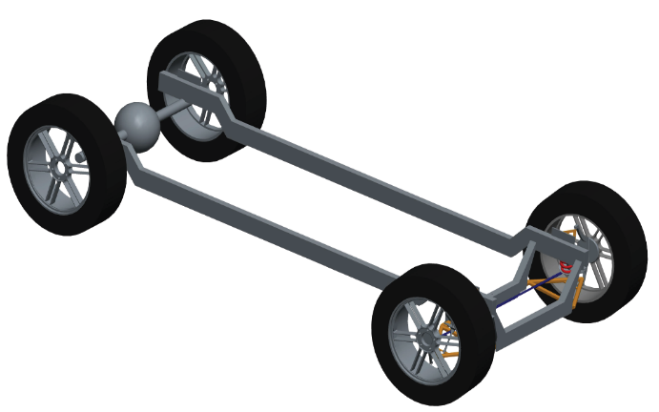 A frame consisting of all aluminum would be ideal, though the amount of extra aluminum support to counteract the drooping of the frame across the span between the front and rear tires would be so thick with the struts, supports, and cross members so much that it would not allow for much room for maintenance of drivetrain components, which is not optimal. This issue led to exploring the idea of a steel and aluminum frame. Consisting of two main steel rectangular supports spanning from the front end components to the rear axle supporting the weight load of the passengers and aluminum frame which will be rested atop of the steel beams, shown on the figure 3.

Figure 3. Steel support beams for aluminum cross members

When consulting with an experienced welder regarding the design of the crossmember the suggestion was made to extend the side beam of the cross member to increase the overall strength of the seat mount. The adjusted crossmember geometry is shown in figure 4.

The considerations for the seat mount on the crossmember to facilitate implementation of mass produced bicycle seats that the sponsor’s bike mechanic can source for a lower price. This includes a 1in diameter seat mounting hole that is the general standard for bike seat posts. This will also provide versatility in the 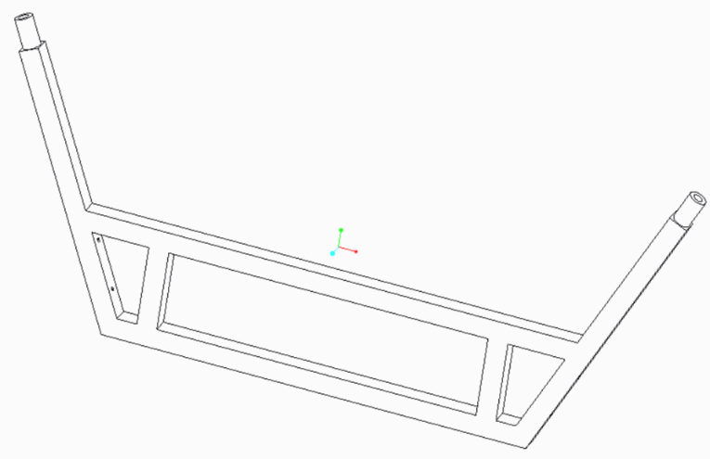design such that if a smaller child will be sitting at a pedaling station, a childs bucket seat can easily be mounted in stead of a standard bike seat.

Figure 4. Finalized cross member geometry

The mounting of the bicycle pedals, crank, and gears to the cross member will be accomplished by two mounting holes on each side beam of the cross member. The entire assembly of the crank mounted onto the crossmember is shown in figure 5. Making the bike components detachable from the crossmember will make them much more accessible to the bike mechanic who will be maintaining the pedibus, the detachable portion will include the pedals, sprocket, and the free wheel.

With the design of the cross member finalized the issue of how to attach the Aluminum cross member to the steel frame is made pertinant. The mount needs to incorporate resistance from the cross member from tipping forward or backward which will be the largest force that the mount will need to resist. Keeping the crossmember from moving laterally will be a much smaller force to prevent from occuring. This is an aspect of bracket design that can be capitolized on, since drilling and removing any material from the aluminum can weaken the material and make the FEA analysis less accurate.

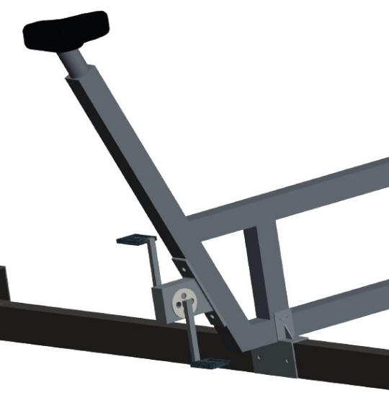The Proposed design of the bracket to fasten the Aluminum cross members to the steel support struts is shown in figure 5, the primary objective of the bracket is to prevent a tipping moment, as well as to secure the aluminum to the lower steel beam. Considerations taken during the design of the bracket are the material of the bracket, steel, and an effort to minimize any drilling into the aluminum, which would jeaprodize structural integrity of the upright within the crossmember. The bracket will be secured to the lower steel beam with nut and bolt through the predrilled 3/8 inch holes in the steel beam and the bracket. Washers and lock washers will be used to ensure the bolt will not loosen with vibration. Securing the crossmember to the bracket will be accomplished in a similar method to how the bracket was secured to the steel frame, except the predrilled holes through the aluminum and bracket will be 1/16 inch. The holes in the aluminum bracket are primarily preventing lateral translation so they do not need to be as large as the holes in the steel beam, as those mounting holes will be preventing the tipping moment of the crossmember which will be a far greater force. To further prevent tipping moments of the crossmember, a triangular flange will be 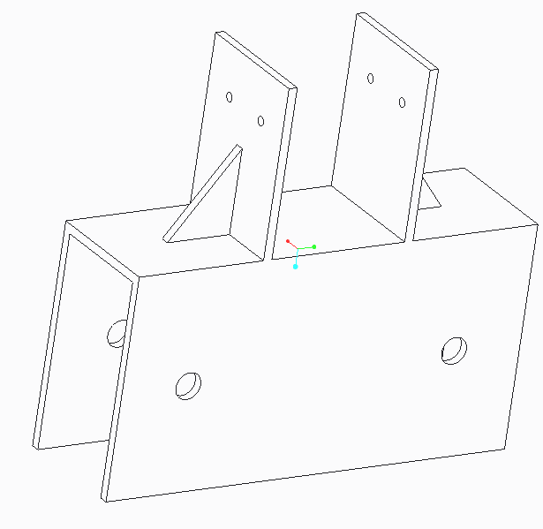preventing anybending of the crossmember mounts. The finalized bracket design is shown in figure 6.

Figure 5. View of bicycle crank and support bracket mount on cross members.

Figure 6. Finalized bracket geometry.

The sponsor of this project wanted to have an adjustable bar top height to accommodate different sized riders. This was achieved by four primary posts protruding through the walking platform above the crossmembers. The posts are mounted and welded to the top of the frontmost and rearmost crossmembers and are linked at the top at corresponding mounting locations of the umbrella top, where gusset plates will be implemented to prevent any sway within the bar posts.

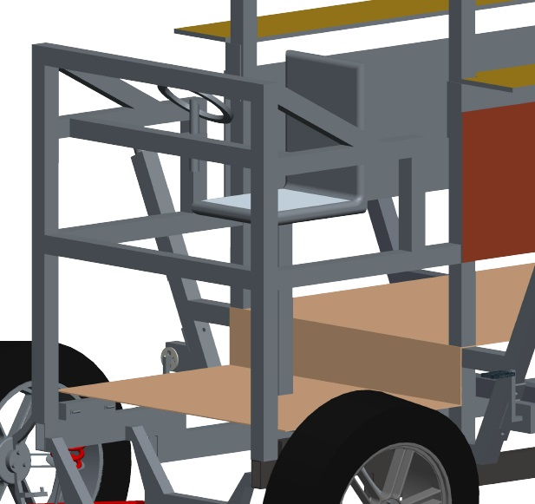The bar will be adjustable upon these posts by a pin and sleeve system where various predrilled holes can be used as different height mounts for the bartop. The material for the bar top will be a hard wood, similar to that of bar tops in restaurants or bars. it will be treated to be moisture resistant, but it will not be as thick or heavy. For safety the bar top will have handle holes cut into it at corresponding locations for each passenger. The aluminum frame will wrap around the front of the pedibus, and will be mounted to the lower steel support via brackets and will be welded to the front two bar posts to further enhace the strength of the bar posts, though the weld location will be below the lowest bar height adjustment setting as to not interfere with the bar top adjustability. A picture of the front aluminum structure is shown in the figure 7.

Figure 7. View of front driving station

**ii. Steering and Braking**

When the Pedibus is traveling and moving along the road, it is important to know the design behind its operating and controlling components. In steering and braking there are various aspects that decide whether a system is desirable or not. For steering there a two basic designs that were taking into consideration. The rack-and-pinion steering system and the recirculating-ball steering system. Both systems are reliable and simple, and after large amounts of research the rack-and-pinion steering was chosen to be the best system for the prototype design. Recirculating-ball steering is often used for heavier vehicles that required gear reduction to reduce the amount of frictional forces for easier steering. In the case of the Pedibus, the unloaded total weight of the vehicle is relatively light to that of a normal automotive vehicle and does not involve complex gear reduction.

*Rack-and-Pinion Steering*

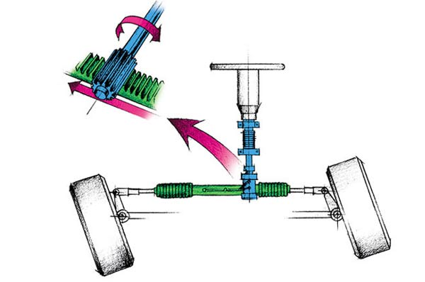Mostly common in earlier date cars and currently common in most automotive and other Pedibus designs. The rack-and-pinion is the most simple gear set used in steering control and is typically enclosed in a metal casing tube. Referring to figure 8 it is noticeable that a pinion gear, located at the bottom end of the steering shaft, is connected to a horizontal gear rack. As the orientation of the steering wheel changes, due to driver commands, the pinion gear will rotate in a fixed position. The interactions with the gear rack will convert the rotational motion of the pinion gear into transitional linear motion of the rack from left to right. At both ends of the rack is attached a tie rod. These tie rods conjoin to the steering rods located at the upright or spindle of the wheels. This series of components allow for the driver to change the direction of the wheels with ease and have complete control of the Pedibus.

Figure 8. Rack-and-Pinion steering system

In order to secure the safety of the vehicle, the passengers,and the public the braking system implemented has to be very tuned and observed in detail for best selection. Most cars today use disc brakes in the front because of the reliability and simplicity of the system. Once researched had been concluded, it was found that disc brakes would also be the best application for the prototype vehicle.

*Disc Brakes*

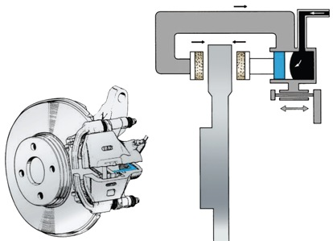The braking system has to be able to bring the loaded assumed 3000lb weight of the Pedibus to a complete and safe stop, for both the driver and passengers. Disc brakes consist of three main instruments: the rotor, the calipers and brake pads, and the fluid brake lines. As the brake pedal is compressed by the driver and force is applied the push rod begins to extract braking fluid out of the master cylinder. Once the fluid has left and travels through the hydraulic brake lines into the secondary cylinder. With constant pressure from the fluid the piston, located at the secondary cylinder, conforms and compresses towards the rotor, seen in figure 9. The piston itself does not come into contact with the rotor, instead there are calipers that are used for contraction. On the inside of the calipers are brake pads on each side of the sidewalls of the rotor. As the brake pads become tighter around the rotor, the kinetic energy begins to convert into heat. The reason for disc brakes being so reliable is that they only respond to the amount of force applied by the driver, securing a safe stopping method.

Figure 9. Completed disc brake and frontal view.

**iii. Power Linkage**

Picking the functional design was made simple by looking at the websites for other Pedibus manufacturers and observing the general principals by which their Pedibuses are powered. What isn’t made clear on the manufacturer’s website is how they link the pedaling power from the passengers to the drive shaft. One problem that is immediately apparent with this design is that passengers on opposite sides of the Pedibus can’t both pedal forward. To address this issue we developed a number of different designs for the linkage between the pedaling station and the drive shaft. Ultimately the team decided that flipping the chains on one side of the Pedibus as they connect to the drive shaft. By flipping the chains the rotational input to the drive shaft is effectively reversed as seen in figure 10.

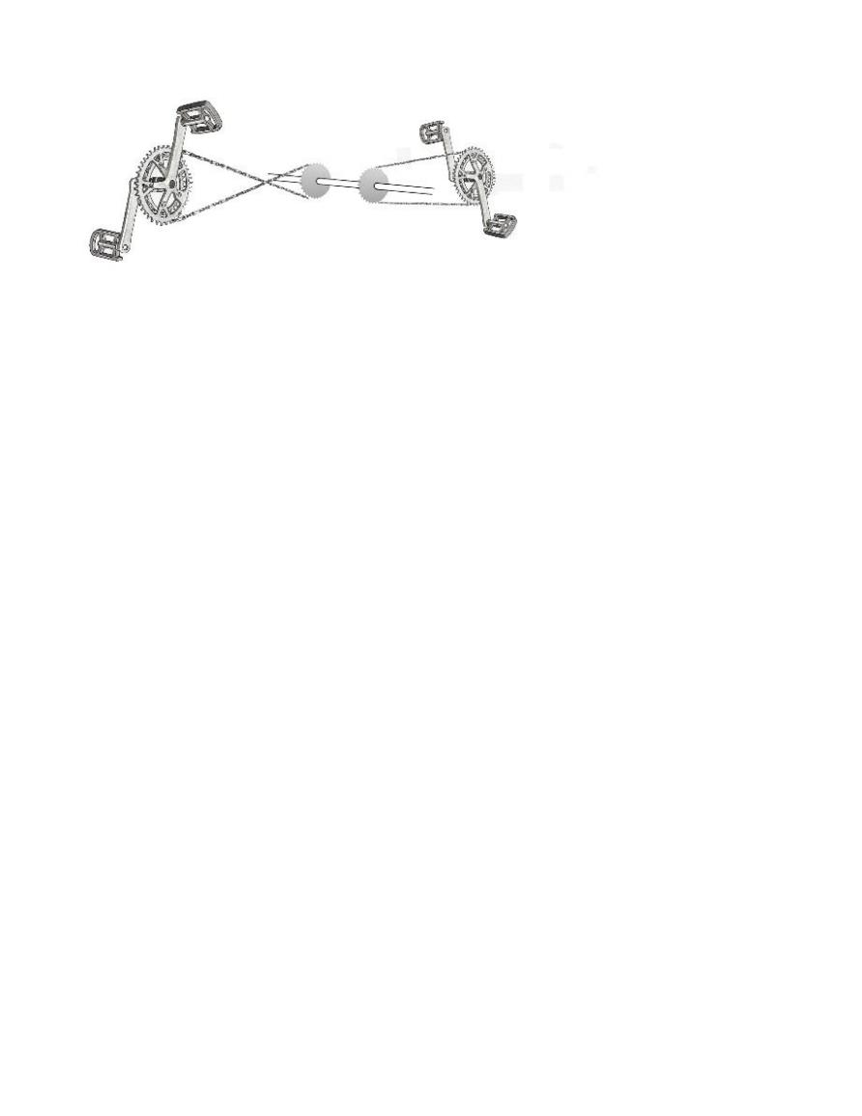

Figure 10. Linkage between the pedaling station and drive shaft

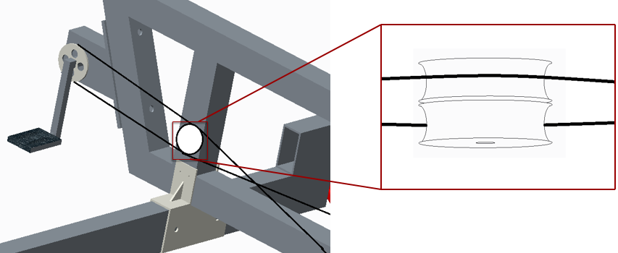The benefits to this design are that all passengers can pedal forward and that it requires very few additional components over other design concepts. Slightly longer lengths of chain will be required for all the pedaling stations on one side of the Pedibus to account for the longer distance required to cross the chains. The negative aspects of this design are minimal. Without adding some additional parts to keep the chain links from rubbing against each other as they cross the life span of the bike chains will be reduced. To counter this potential reliability issue a set of pulleys will be installed to guide the chains around each other. A 3D model representation of what this would look like on the final Pedibus prototype can be seen in figure 11.

Figure 11. Pulley placement on cross member

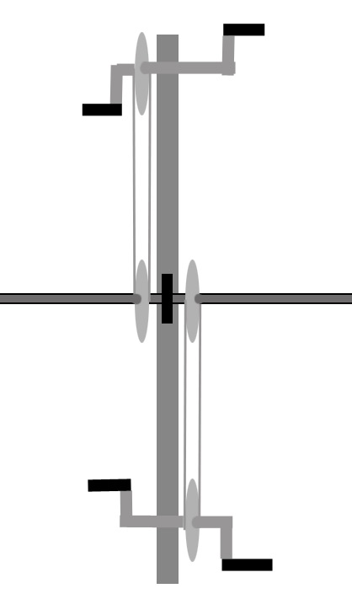In the initial visualization of the power linkage it was believed that the pedaling stations would have to be offset from each other so there would be room for all the gears on the bike shaft. This configuration can be seen in figure 1. After designing the frame it was decided that the pedaling stations could be attached to the same cross member support and the pedaling gears and chain installed on the cross member as seen in figure 12. This layout for the pedaling mechanism allows for a less complicated assembly of the Pedibus.

Figure 12. Top view of cross member with bike components.

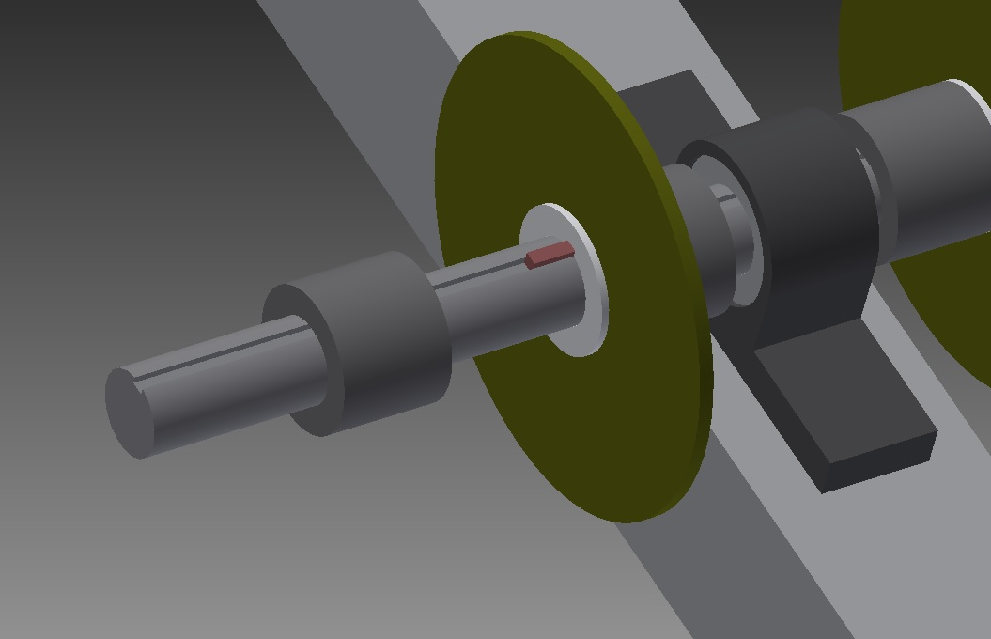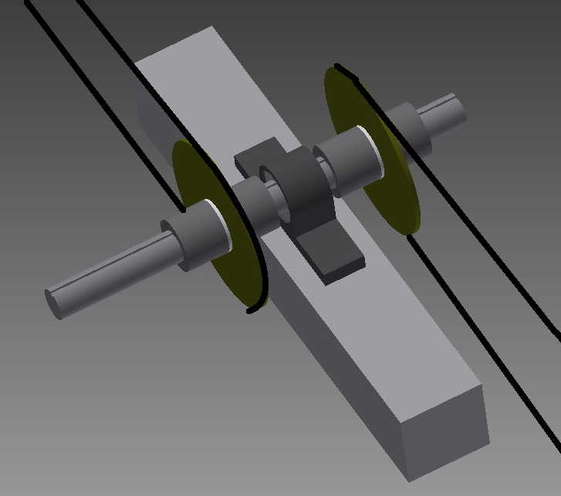The drive shaft itself will be ¾ inch cold rolled steel rod. The drive shaft will be connected to the structural frame of the Pedibus by pillow blocks which will be bolted to the undersides of the four cross members that make up part of the structural frame of the Pedibus. Figure 13 gives a better reference as to where on the Pedibus these pillow blocks will be installed. It can also be seen from figure 14 that the drive shaft will be keyed so that the bike gears can be attached to the drive shaft without having to be welded onto the shaft. The key between the drive shaft and the bike gear hub keeps the bike gears rotation locked to that of the drive shaft. Two collars with set screws are installed on either side of each gear so that the gear doesn’t slide on the drive shaft. This allows for easier maintenance of the Pedibus in that if one of the gears breaks the collars and gear hub can be removed, the gear slipped of the shaft, and a new one slipped back on in its place. It is important to note that if the middle gear breaks all gears between that gear and the end of the drive shaft will also have to be removed which is much easier to do with gears keyed to the drive shaft than with gears welded to the drive shaft.

Figure 14. Keyed drive shaft assembly

Figure 13. Bike gear and pillow block assembly

The drive shaft is connected to a repurposed rear axle of an automobile. The driveline input for the differential has a larger diameter than the ¾” driveshaft it is being connected to. A piece of A36 cold rolled steel round stock 2.5” in diameter will be machined to fit inside the driveline of the rear differential and will have a ¾” hole bored through it to fit the drive shaft. The pieces will then be pinned or welded together to bridge the connection between the drive shaft and rear differential. The rear differential being sought after is the rear end of a Toyota T100 truck. The Toyota T100 has a rear differential gear ratio of 3.08:1. The differential gear ratio is an important figure to know for calculating the bike gear ratios between the drive shaft and the pedaling stations as will be explained in that portion of the analysis section later in this report. The rear axle transmits the power input by the driveshaft to the rear tires of the Pedibus.

The tires chosen for this vehicle were chosen based on their coefficient of rolling resistance. As is explained in further detail in the analysis section of this report the dominant force that must be overcome to maintain the desired cruising speed of the Pedibus is the force of rolling resistance. The easiest way to minimize the force of rolling resistance is to pick a tire with the lowest coefficient of rolling resistance. The Michelin Symmetry P225/60R16 has a rolling resistance coefficient of 0.0065 making it one of the lowest rolling resistance full sized tires on the market. The tire fits a 16” rim and has a total inflated diameter of 26”.

**C. Dynamic Analysis**

Knowing the design and skeleton behind the development of the Pedibus only deals with the functional and aesthetic image of the vehicle. The real success of the project is due to the mathematical and computer dynamic analysis that went into every component. Knowing characteristic properties and limitation, eliminates room for error and undesirables results.

1. **Structural Frame**

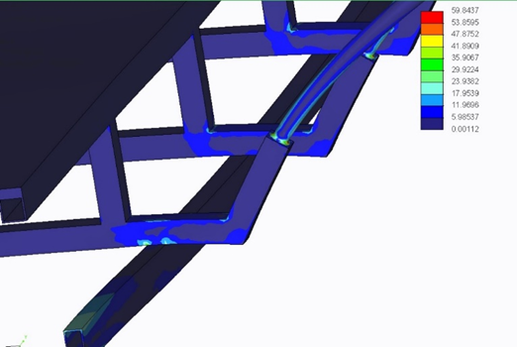The design of the cross member was a dialing in process, FEA analysis was used to ensure that the design of the cross member would complement the lower steel beams in a fashion which yielded the maximum strength possible. The initial design for the incorporation of an aluminum and steel frame yielded less than comforting FEA static load analysis results. Shown in figure 15 is the results of the static load analysis of the first proposed design of the cross member. The analysis was performed with a uniform distributed load of 1000 lbs. across the diamond plate aluminum platform that rests atop the 4 cross members and an additional load of 300 lbs. was placed at the seat mounts of each of the 8 pedaling stations. The areas of light blue are stresses above the yield strength of aluminum and the blue areas are areas of stresses that are near the yield stress of aluminum. The results of this test were concerning and the design of the aluminum cross member was modified and reanalyzed.

Figure 13. FEA analysis of initial aluminum cross member design

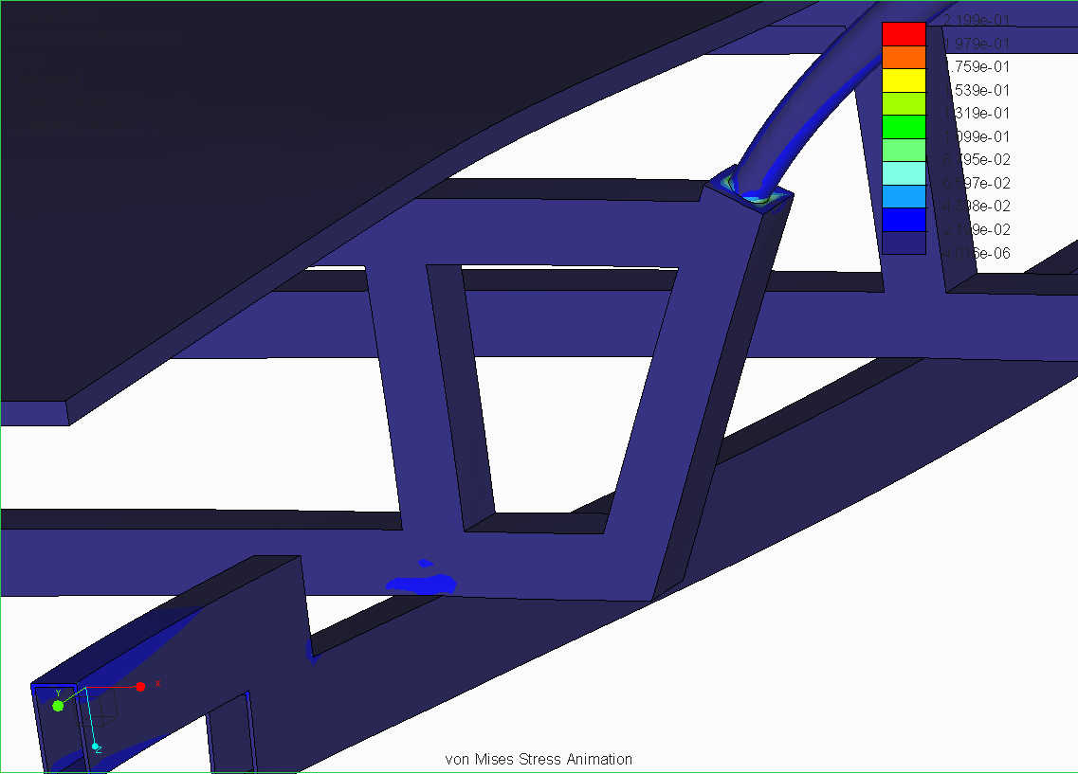The modifications made to the cross member include positioning the cross member uprights above the steel beams and pulling the side beams in closer toward the steel supports. As shown in the static load analysis of the frame after the adjustments were made to the cross member in figure 16, the areas of stresses have been greatly reduced and there is no stresses above the yield strength of aluminum present.

Figure 14. FEA analysis for modified cross members

**ii. Steering and Braking**

With the decision to use rack-and-pinion steering the Pedibus is going to have an automotive vehicle steering feel. The driver will turn and control the vehicle by means of a common steering wheel. Since the Pedibus is made as an entertainment console and is not going to be operating at high speeds, the turn radius is going to have to be able to make tight corners. The sharpness of the turn and responsiveness is due to the pinion diameter and gear rack length. The maximum turning angle of a normal rack-and-pinion steering is at about 60 degrees. This large angle allows the Pedibus to take tight corners when the steering wheel is rotated fully.

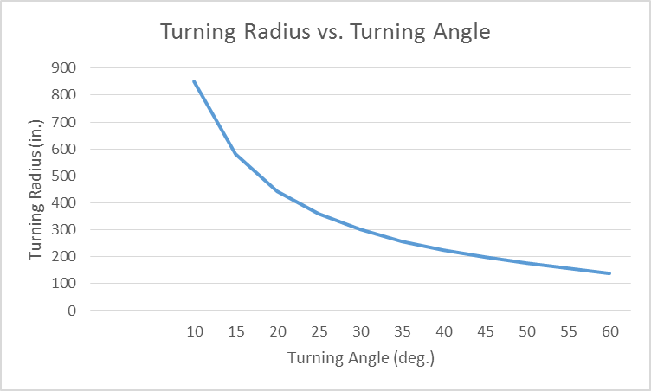

Figure 15. Analytical graph of turning radius vs. turning angle

Looking at the graph in figure 17, It can be observed that as the turning angle begins to increase, in degrees, that turning radius reduces as a result. This is a normal characteristic of steering and proves desired results. A balance equation was used to find the opposing lateral forces that may be applied during cornering. Detailed mathematical analysis and equations are performed in the appendix.

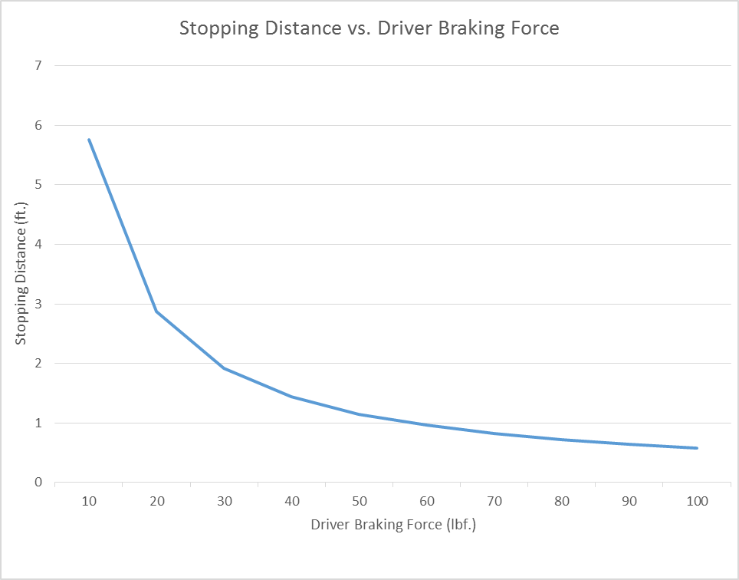Once the Pedibus is in motion, the next concern is bringing it to a safe and complete stop. The braking force is applied by the front central driver and controls the distance that the Pedibus will come to a stop. An assumption of the driver weighing around 200 lbs. was made to give an assumed applied braking force of between 0 lbf when no force is applied, to 100 lbf when maximum force is applied. Forces that had to be overcome, and are detailed in the appendix, included: the brake pedal, brake pads, calipers, friction of rotor, and fluid pressure forces, as well as the tire forces. A graph was compiled, as seen in figure 18 that shows if the assumed driver were to apply any force greater than 40 lbf. that the Pedibus will stop within one foot. Also we can conclude, the slower and softer the driver exerts force to the brake pedal the slower that rate of stopping as well. The results put confidence into the brake system chosen as it provides a safe and efficient stopping method.

Figure 16. Analysis of stopping distance vs. driver braking force

**iii. Power Linkage**

*Power Input Requirements*

A question of central importance when designing a human powered vehicle is, “how much power must be generated to move the vehicle at the desired speed?” In the case of the Pedibus it is important to know how much power each passenger must generate under different scenarios. The amount of power a person can generate varies greatly between people. Some general numbers of what people can generate are given as reference in table 1. The powers calculated in table 1 are based on average output for one hour of performing the exercise activity. Based on these numbers, and some experimenting on a cycling machine at the gym, it was determined that a constant power output of less than 60W was desirable so that powering the Pedibus was not too tiring.

Table 1. Average Human Power Generated for Activities

|  |  |
| --- | --- |
| ACTIVITY | AVERAGE POWER OUTPUT For 1 Hour (Watts) |
| Walking at 3mph | 30W |
| Average person bike racing | 120W |
| Regular cyclist racing | 220W |
| Professional cyclist racing | 300W |
| Lance Armstrong racing | 400W |

Analysis was done on the power requirements to maintain a cruising speed of 5mph and to accelerate to 5mph from rest. Analysis of the power required per passenger based on total number of passengers and traveling velocity will also be discussed.

*Maintaining cruising speed*

The desired cruising speed for the Pedibus is 5mph. To maintain a speed of 5mph the forces that must be overcome are the force of drag, rolling resistance, and the force required for any change in elevation. If it is assumed that the Pedibus is traveling on level ground and there is no change in elevation then the force of drag and rolling resistance are the only forces. Equation (1) is the equation for calculating the drag force on the Pedibus at a given speed. Assuming $v$ is our desired cruising speed of 5mph and the coefficient of drag ( Cd) is assumed to be 1.05 ( the drag coefficient of a flat plane normal to wind velocity) The force of drag on the Pedibus is found to be 8 N. Using Eq. (2) this represents a power input of about 17W.

$F_{d}=\frac{1}{2}ρv^{2}C_{d}A$ (1)

$P=F*v$ (2)

The force of rolling resistance can be calculated using Eq. (3). The coefficient of rolling resistance (Crr) of the tire chosen for use on the Pedibus is 0.0065. All calculations for rolling resistance were made assuming that the tire would have a higher Crr of 0.01 when supporting the weight of the Pedibus and passengers. With this assumed value for Crr and an assumed loaded weight of 2750lb (weight of Pedibus and eight 250lb passengers) the force of rolling resistance was found to be 123N. To maintain a speed of 5mph it takes 275w of power to overcome rolling resistance. From these values it can be seen that rolling resistance is the dominant resistant force at the velocities the edibus is designed to travel at. If all passengers are pedaling with equal power input (equal torque on the pedals at the same rotation speed) each passenger would need to generate 37W of power to maintain a traveling speed of 5mph.

$F_{rr}=Mass*gravity*C_{rr}$ (3)

*Reaching Cruising Speed*

Equation (4) represents the sum of the forces acting against the Pedibus while accelerating. The force of rolling resistance (Frr) and the force of drag (Fd) have already been calculated. The force of acceleration (Fa) is calculated with Eq.(5) . There is no acceleration rate requirements for the design of the Pedibus. The Pedibus team determined that if the Pedibus starting from rest could reach a cruising speed of 5mph 20 seconds that would be sufficient rate of acceleration to accomplish all the need of the Pedibus. This represents an acceleration of 0.367 $\frac{ft}{s^{2}}$. The power required to achive this acceleration varies with traveling velocity. Since acceleration to cruising speed represents such a small portion of the traveling time the Pedibus teams analysis was focused on the maximum power input required to reach 5mph if accelerating at a constant rate of 0.367 $\frac{ft}{s^{2}}$ as opposed to average or total power input required. The max power input required to move the Pedibus from rest to 5mph can be determined using Eq. (6). The maximum power required to accelerate the Pedibus was determined to be 604W. This represents a power input of 75.5W per passenger. While this is above our desired power output of 60W it is for a very short period of time and is thus acceptable.

$F_{total}=F_{d}+F_{rr}+F_{a}$ (4)

$F_{a}=Mass*Acceleration$ (5)

${ P}_{max}=\left(F_{d}+F_{rr}+F_{a}\right)v_{max}$ (6)

*Traveling with less than full capacity*

An objective of this design project, set at the beginning of the semester, was that the Pedibus be able to be power by as few as 2 passengers. The equations mentioned previously in this section were used to generate fig. 19, a graph of the power required to maintain 5mph based on number of passengers, and fig. 20, a graph of the power required to accelerate to 5mph based on number of passengers. From these graphs it can be seen that, while it will require more than double the power, two passengers could accelerate the Pedibus to 5mph with 168 W of power input each, and could maintain it at that speed with 83W of power input each. While these power inputs are higher than the ideal limit of 60W per passenger they are low enough that two people in average shape can power the Pedibus for at least an hour before tiring.

Figure 17. Watts per Passenger to maintain 5mph Velocity vs. Number of Passengers.

Figure 18. Maximum Power Required per Passenger to Accelerate from Rest to 5mph in 20 seconds

*Traveling up an inclined slope*

All analysis on the power requirements for moving the Pedibus discussed up to this point in the report have assumed the Pedibus was traveling on level ground. The topography of Tallahassee is more like that of southern Georgia than it is like that of the rest of Florida in that it has a number of significantly sized hills. Because of this when designing a vehicle to be operated in this area it is not reasonable to assume the vehicle will travel on level ground. Assuming an incline of 7% Eq. (7) can be used to calculate the additional force acting against the Pedibus as it is traveling uphill which was determined to be 931N. This is more than double the force acting against the Pedibus as it travels on level ground and represents an additional power requirement per passenger of 300W per passenger. This mean each of the eight passengers will have to generate 340W of power to climb a 7% incline at 5mph. Referencing table 1 it is clear that very few passengers who travel the Pedibus will be able to generate that amount of power. A slower travel speed is required for traveling uphill. Figure 21 is a graph of power requirement per passenger based on the vehicle velocity being maintained. From the graph it was determined that while traveling up an incline the vehicle speed will have to be reduced to 1 or 2 mph unless electric motor assistance is used.

$F_{slope}=Mass*\sin\left(θ\right)*gravity$ (7)

Figure 19. Power Required to Ascend 7% slope Vs Velocity

*Passenger pedaling RPM Analysis*

Not only is it important that the passengers have a reasonable required power input to move the Pedibus, it is also important that the passenger pedaling rpm also be reasonable. Comfortable pedaling rpm are between 50 and 80 rpm for bicycling and will serve as the range of possible pedaling speeds for the Pedibus. With a tire diameter of 26” the wheels of the Pedibus rotate at 65rpm while the Pedibus is traveling at 5mph. The 3.08:1 gear ratio of the rear differential means the drive shaft spins at 200rpm which is too fast a rotation speed to achieve at the pedaling station. To correct this issue a 3:1 gear ratio will be used between the pedaling station and the drive shaft (the gear at the pedaling station being 3 times bigger than the one on the driveshaft). This gear ratio makes the rpm at the pedaling station 66rpm which is in the middle of our comfortable pedaling range. The variable that govern this ratio are the tire diameter and the rear differential gear ratio. If wither of these values are changed the gear ratio between the pedaling station and drive shaft will have to be adjusted.

**IV. Risk and Reliability Assessment**

Public safety and eco-friendly are two of the most stressed parameters of the Pedibus development project. There are always uncertainties and possibilities of risk that may arise and it is one the development goals to eliminate as many of these factors as possible. The factors that can affect the public or vehicle safety will be listed below, but its important to discuss the procedure behind deciding which are the most important to evaluate. If the situation were to injure the passengers, surrounds public, or environment then precautions must be taken to reduce to chances. Certain scenarios, but not limited to, may be:

* The weight of the vehicle effecting pedal power after long periods of time.
* Without the use of seatbelts, the probability of a passenger falling has increased.
* Pedaling the vehicle up an inclination without requiring maximum effort
* Frictional forces due to road and tire conditions
* Environmental conditions that may affect to condition and wear of individual components

Much observation, evaluation, and mathematical analyzing has been conducted to ensure to construction of a safe a reliable Pedibus prototype. Reliability not only protects the public but also provides reinsurance for possible reproduction of the developed prototype.

**V. Detailed Design and Design for Manufacturing**

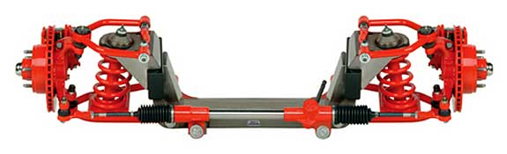After much evaluation and analyzed data, the final design for the road-ready Pedibus prototype has been decided and is ready for manufacturing. The complete vehicle shown in figure 22 will contain all features previously mentioned and discussed as well as all the road safety features. The prototype contains a central drive shaft, along with all other mechanical components (pedals, chain links, wheels, steering, suspension, etc.) and also a front driving station. For investor reasons there Pedibus will have room for advertising and open space in the rear that will allow room for an extra bench seat, or ice cream cooler, and even a beer dispenser if desired. The front axle will also be bought as a unit, specifically the Mustang IFS II, seen in figure 22. This will allow for easier assembly and ensure all the parts fit and operate properly.

Figure 20. Complete assembly of Mustang IFS II front beam axle.

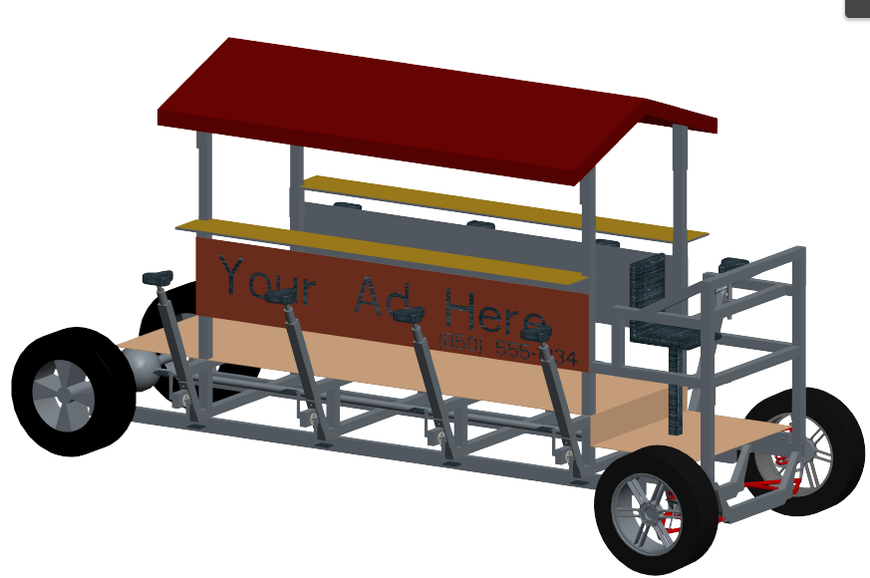

Figure 21. Scale model of the road-ready Pedibus prototype design

**VI. Procurement**

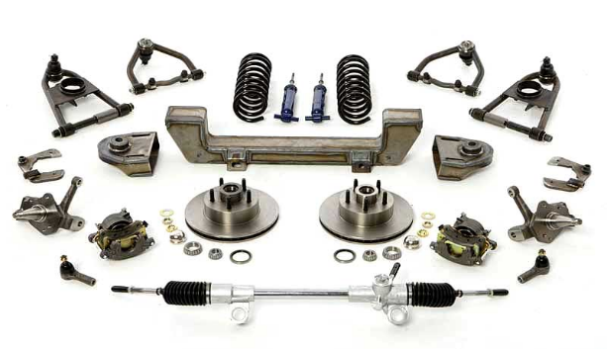The sponsor Ron Goldstein has offered to purchase all of the components to avoid the delay of ordering components through the engineering school. Dr. Amin advised the team have the sponsor purchase components for this very reason. The aluminum and steel will be acquired by ordering online from www.discountsteel.com

The front end of the Pedibus will be ordered from http://www.fulltiltstreetrods.com. It will include the brake calipers, rotors, wheel hubs, suspension and steering system all in one. The assembly will cost $1200 with free shipping off of eBay. Once received, it can be welded directly to the steel portion of the frame. The steering wheel will be sourced from eBay as well. The linkage rods and universal joints connecting the steering wheel to the rack and pinion steering will be sourced from McMaster-Carr. The brake pedal and master cylinder will also be sourced from eBay.

Figure 22 All the components included in the front beam assembly

The rear differential of the Pedibus will be obtained by visiting the local pick and pull and using an angle grinder and cutting the U-bolts that hold it onto the box springs of the Toyota T-100.The system which will be harvested and the differential including the wheel hubs will be around $140.

The pedaling stations and bike components, such as bike seats, pedals, pedal arms, sprockets, and chain, and overlap pulleys will be sourced by a cooperating bike mechanic who owns his own shop and will be able get a discount wholesale price Most of these components have already been picked and sourced. The bike mechanic has advised waiting until after the holidays until ordering; as there is always a price drop on bike components after the holidays.

The tires and wheels will be sourced and purchased locally, the actual choice on rim style has not been made and it is up to the sponsor to pick his preference. Although it is possible that the hubs on the rear axle do not have the same lug pattern as the front end, this is not an issue. Team members are aware of this and it will be possible to procure the same design of wheel with a different lug pattern as to retain aesthetic consistency. The tire size has been chosen, as well as tire model. The tire that was picked was chosen due to its low rolling resistance.

**VII. Communications**

The success of this project until this point has been due to the consistent and positive communication between the sponsor and team members. Biweekly meeting with the instructor and faculty advisors have allowed for positive and guiding feedback that promoted advancements in the development stages of the project. Communications have also been made with outside resources for individual part sourcing and construction guidance. We hope as a team, to keep to strong communication and cooperation to resume into the following semester not only among members, but also with the sponsor, instructor, and advisors as well.

**VIII. Conclusions**

The midyear progress in the design of the Pedibus development has met all the expectations set at the beginning of the semester by the team and sponsor. The vehicle now accommodates the request for variable seating heights to allow wide age group. The weight and strength of the vehicle needed to be light yet strong under pressure. After evaluating multiple materials, a combination of both aluminum and steel was chosen for the structural frame. This combination not only provides a low cost, but also a high strength to weight ratio to confirm maximum strength and light weight. The reduction being 26% less than the initial all steel weight. The Pedibus being generated by pedal inertia involves a series of various linkage systems connected to the main drive shaft. By crossing the chains to allow both sides to peddle forward the comfort and appeal will be a lot greater and produce the most inertia. The free wheel being at the pedals instead of on the drive shaft was the best design for the ease of maintenance. The rack-and-pinion steering, disc brakes, suspension, motor accelerator and center steering column allows the driver to be comfortable and have an automobile driving experience. The rear of the drive shaft will be connected to a differential that will translate the longitudinal rotation into lateral rotation that turns the wheels. Once the vehicle was initially designed, external forces were found to have great effect due to the total weight and the generated power. Choosing the lightest wheels reduced the weight and picking the tires with the lowest rolling resistance loosened the effect of tire friction. The other option that is also implemented is the support of an electric DC motor to provide acceleration and driving capabilities. The overall budget for the manufacturing of the Pedibus development fell below estimated budget that gives room for the greater possibility of reproduction.

**IX. Environmental and Safety Issues**

The sponsor provided the initial idea of the Pedibus to be completely eco-friendly with zero gas or fume contribution. To prevent the use of gas, the power assist motor will be a high torque electric DC motor powered by a rechargeable battery pack. The Pedibus will be driving on public roads and thus must apply by the state laws. For the safety of the public the vehicle must poses headlights, tail lights, turning signals, driver seat belt, and a rear view mirror to monitor rear traffic. To ensure safety to the passenger riders all exposed chain links will be covered by folded sheet metal and handles will be placed on the bar for support.

**X. Future Plans**

Leading into the spring semester the construction and final development stages of the Pedibus are going to begin. The future of this project will rely on the close contact with the sponsor and advisors. To further progress in the development, the following are going be taken into action to complete the construction of the prototype.

* Order raw material and parts for construction of Pedibus
* Source bicycle components by meeting with local bike mechanic
* Find and refer outside resource for assistance in Pedibus assembly
* Run performance test for completed prototype assembly.
* Implement all the request from future investors, while maintaining safety and cost concerns.

**XI. Budget and Resources**

The budget has been one of the limiting factors in the progression of this project. With an initial budget of only $2000 for a vehicle that MSRP’s at around $30,000 - $40,000 the teams’ confidence was not too high for possible completion. After having constructive meeting with the sponsor and future investors, a new budget of $5000 was granted and gives enough room for material and assembly cost. A list of bill of materials with respected prices is listed below in table 2. All parts were chosen based off reliability and cost effectiveness.

Table 2. Bill of materials with respected cost price

|  |  |  |  |  |
| --- | --- | --- | --- | --- |
| BOM |  | # | Price Per Item | |
| Steel Supports |  | 2 | $69.00 | $138.00 |
| Aluminum Frame |  | 1 | $389.00 | $389.00 |
| Pillow Blocks |  | 4 | $30.00 | $120.00 |
| Steel Frame |  | 1 | $218.00 | $218.00 |
| 3/4 inch Cold Rolled Drive Shaft |  | 1 | $100.00 | $100.00 |
| Mustang II Ifs |  | 1 | $1,100.00 | $1,100.00 |
| Rear Axle and Differential |  | 1 | $300.00 | $300.00 |
| Bike Crank |  | 8 | $45.00 | $360.00 |
| Bike Seat |  | 8 | $17.00 | $136.00 |
| Bike Chain |  | 8 | $30.00 | $240.00 |
| Free Wheel gear |  | 8 | $25.00 | $200.00 |
| Wheels |  | 4 | $104.00 | $416.00 |
| Electric Motor & Controller |  | 1 | $880.00 | $880.00 |
| Battery |  | 1 | $53.00 | $53.00 |
| Lighting Kit |  | 1 | $170.00 | $170.00 |
| total |  |  |  | $4,820.00 |

**XII. References**

[1] "How Car Steering Works." *HowStuffWorks*. N.p., n.d. Web. 2013.

[2] Pedal Crawler | Custom Party Bike Manufacturer. 2013. *Pedal Crawler | Custom Party Bike Manufacturer*. <http://www.pedalcrawler.com/>.

[3] The Party bike <http://www.thepartybike.com/index.php/the-party-bike/>.

[4] PedalPub. The Bike with the Barrel. 2013. *PedalPub. The Bike with the Barrel*. <http://www.pedalpub.com/>.

[5] <http://www.capitalcitypedicabs.com/CCPedicabs/home.html>

[6] Pedibus - Beer bike, pubcrawler, pedibus, bike bar, cycle pub, cycling pub, cycling bar, bike pub, bike car. <http://www.pedibus.co.uk/>.

[7] Grainger Industrial Supply - MRO Supplies, MRO Equipment, Tools & Solutions. *Grainger Industrial Supply* <http://www.grainger.com/Grainger/wwg/start.shtml>.

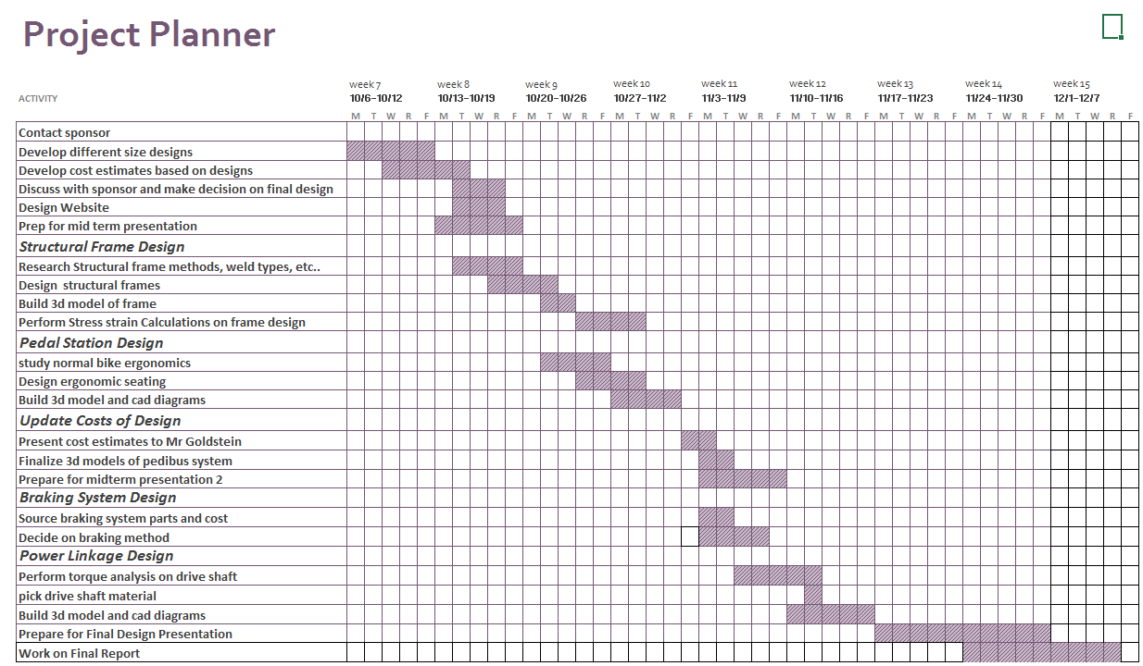

**Appendix**

List of equations and solutions

Equations:

$F_{d}=\frac{1}{2}ρv^{2}C_{d}A$ (1) Force of drag

$P=F*v$ (2) Power

$F_{rr}=Mass*gravity*C_{rr}$ (3) Force of rolling resistance

$F_{total}=F_{d}+F_{rr}+F_{a}$ (4) Total force to accelerate

$F_{a}=Mass*Acceleration$ (5) Force of acceleration

$P_{max}=\left(F_{d}+F_{rr}+F_{a}\right)v_{max}$ (6) Max Power (accelerating)

$F_{slope}=Mass*\sin\left(θ\right)*gravity$ (7) Force of traveling up slope

Unloaded weight of the pedibus

Assuming everyone riding the pedibus weighs 250lb

Variable for number of passengers



Cruising velocity of 5mph

density of air





Assumed area of 5 ft wide and 5ft tall for front of vehicle









Equation (1) for calculating drag force

Equation (2) for calculating required power overcome drag at cruising velocity

Coefficient of drag for a flat plane normal to the wind direction

coefficient of rolling resistance our tires claim 0.0065 but used 0.01 to be conservative





Equation (3) for calculating rolling resistance force





Required power to overcome rolling resistance based on # of passengers





assumed acceleration of 0 to 5mph in 20 seconds





Equation (5) Force required to accelerate pedibus

rolling resistance force based on # of passengers





Max power required to accelerate

power required approaches this value as velocity approaches 5mph







Power required to accelerate based on # of passengers



Power requires to maintain cruising speed of 5mph



Power required per passenger to maintain 5mph















Force values with eight passengers





total power required with variable velocity



total power required to climb slope based on velocity



Power required per passenger based on velocity



Steering Analysis

Static Load Distribution

The assumed weight distribution is 50/50 front to rear.

Initial assumption of vechile being 140" in total length





Moment being about the center of gravity:







During Cornering:

Centrifical Force = Cf



(minimum assumption)



(maximum angle)





Lateral Forces:















Braking Analysis

**All inital conditions are based off estimated assumptions











Energy of vehicle in motion into thermal energy





The brake pedal

Assume weight of driver is 180 lbs

Force exerted by driver onto foot pedal:











Bore diameter of master cylinder = bmc





Hydraulic pressure transmitted to the calipers:

(Assuming 100% efficiency)





The Caliper

Piston diameter = dp













The Clamp





The Brake Pads

The coefficient for a brake pad is typically betweenn 0.3 to 0.7

For our concerns we will assume an average of 0.5 for the coefficient of friction (μ bp)







The Rotor

Reff = the effective radius of the rotor (measured from the rotor center of rotation to the center of pressure of the caliper pistons)











Since the effective rolling radius is hard to measure without real-time testing we are going to use the loaded rolling radius instead (center of wheel to contact point with horizontal surface)











Deceleration of Pedibus in motion





The Tire

(Accounts for all four tires)



Stopping Distance



